**Relational Model:**

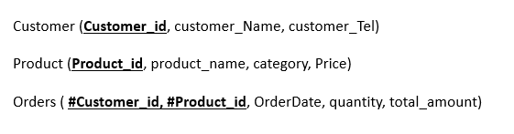

**Data table :**

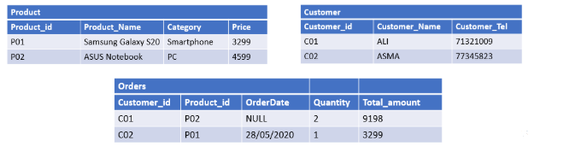

**SQL commands:**

INSERT INTO Customer VALUES (‘C01’, ‘ALI’, ‘71321009’);

INSERT INTO Customer VALUES (‘C02’, ‘ASMA’, ‘77245823’);

INSERT INTO Product VALUES (‘P01’, ‘Samsung Galaxy S20’, ‘Smartphone’, ‘3299’);

INSERT INTO Product VALUES (‘P02’, ‘ASUS Notebook, ‘PC’, ‘4599’);

INSERT INTO Orders (Customer_id, Product_id, Quantity, Total_amount) VALUES (‘C01’, ‘P02’, ‘2’,’9198’);

INSERT INTO Orders VALUES (‘C02’, ‘P01’, ‘28/05/2020’,’1’,’3299’);